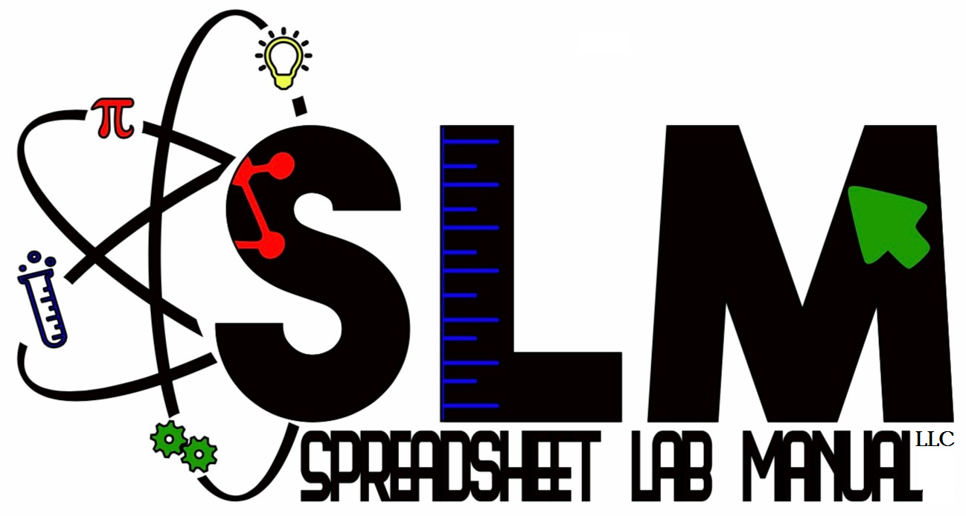

Dear STEM Educator:
You are cordially invited to participate in a federally funded, public educators’ research study targeting student data fluency in high school STEM. Participants will pilot an automated, computational, spreadsheet modeling professional development (PD) training program. This program was developed as part of National Science Foundation Small Business Innovation Research (NSF SBIR) Phase 1 Award by Spreadsheet Lab Manual LLC, with support, cooperation and IRB approval through Rowan University. Modeling applications and procedures cited in training videos were adapted from The Spreadsheet Lab Manual (SLM). SLM provides classroom-ready, spreadsheet modeling instructional materials for STEM teachers. All participants are given permanent copyright licensure for all linked NGSS aligned educational materials and a certificate documenting completion of (1) hour of professional development training. Also, as compensation for your valuable time, Spreadsheet Lab Manual LLC is providing each participant with two $10 gift cards, one at consent and another upon task completion (or opting out).
You will be provided a link to respond to a brief (3-5minute) questionnaire. Your response data will be managed by Dr. Trevor Smith of Rowan University, who will ensure the anonymity of your responses by providing them for review only in aggregate. Responses will never be connected to any identifying information of those who provided them. Participation in all aspects of this research is voluntary and does not require or assume subsequent enrollment or membership, and you can withdraw or opt out at any time and keep the $10 gift card. Study survey responses could potentially influence decisions regarding technical product development or training pedagogy, and further may be quoted or taken into consideration by NSF review panelists toward outcomes of future funding opportunities. As the outcome of this taxpayer-funded study is in the public interest, your professional opinion helps ensure that public funds are allocated most efficiently toward the goal of supporting and enhancing student learning outcomes.
My name is Michael McConnell, and I am currently working as the principle investigator of this study. For the last 15 years I taught high school physics and worked to give students data fluency on spreadsheets. As of the end of the 2018-19 school year, I left the classroom to work full time representing Spreadsheet Lab Manual LLC, the company I founded to propose this research and development to NSF and to be available full time to train STEM teachers as a PD provider, specializing in computational spreadsheet modeling. The study goal is to efficiently and remotely train teachers in computational modeling at their convenience. My goal is your students’ success, because that is what matters to you, and it is the first step to helping all students succeed across the USA. By investing early and entrusting your time with SLM training, both you and the group will experience lasting learning value added. Leveraging the computational power of modern spreadsheets, the internet, and the collective strength in our diversity and numbers, teachers will define the future of this fundamental advancement in STEM learning capability for all of humanity.
SLM Training Study Instructions Link (Choose 1): Rocket Science (Excel) or Rocket Science (Sheets)

Post Submission Study Survey Link: https://rowan.co1.qualtrics.com/jfe/form/SV_9HOnBq1k779XGmN

Please feel free to contact us if you have any questions regarding any aspect of this research study. Thank you.

Sincerely,

Michael McConnell, Principle Investigator Trevor I. Smith, Assistant Professor
President/Founder Department of Physics and Astronomy
Spreadsheet Lab Manual LLC Department of STEAM Education
http://www.spreadsheetlabmanual.com Rowan University
(856)418-6065 Office: 101I Science Hall
michaelmcconnell@spreadsheetlabmanual.com (856)256-4848
smithtr@rowan.edu

